Project Design Phase-II
Data Flow Diagram & User Stories

Date | 3 Jul 2026
Team ID
Project Name | Comprehensive Analysis and Dietary Strategies with Tableau: A College Food Choices Case Study
Maximum Marks | 4 Marks

Data Flow Diagrams:
A Data Flow Diagram (DFD) is a traditional visual representation of the information flows within a system. A neat and clear DFD can depict the right amount of the system requirement graphically. It shows how data enters and leaves the system, what changes the information, and where data is stored.

FLOW:
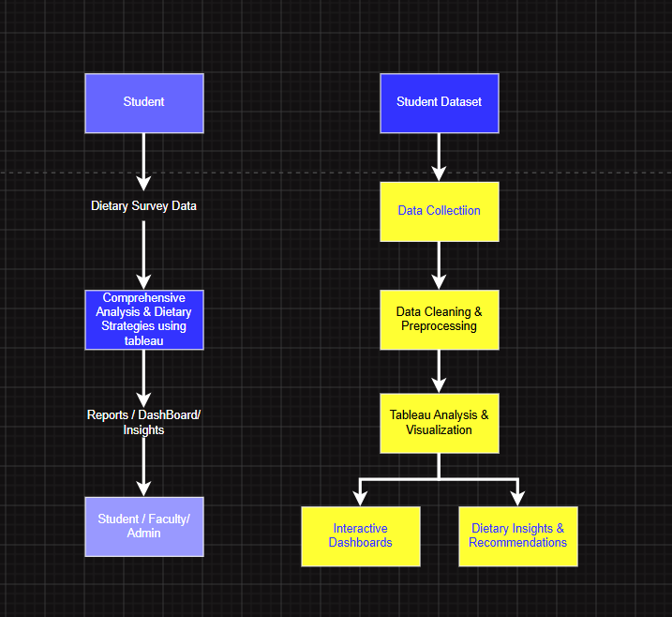

User Stories
Use the below template to list all the user stories for the product.
User Type | Functional Requirement (Epic) | User Story Number | User Story / Task | Acceptance criteria | Priority | Release
Student | Data Import | USN-1 | As a user, I want to import the dietary dataset into Tableau. | Dataset imports successfully without errors. | High | Sprint-1
Student | Data Cleaning | USN-2 | As a user, I want to clean missing and inconsistent data before analysis. | Clean dataset is ready for visualization. | High | Sprint-1
Student | Dashboard | USN-3 | As a user, I want an interactive dashboard to explore dietary habits. | Dashboard loads with filters and charts. | High | Sprint-1
Student | Nutrition Analysis | USN-4 | As a user, I want to analyse calorie intake and meal frequency. | Dashboard displays nutrition metrics correctly. | High | Sprint-1
Student | Lifestyle Analysis | USN-5 | As a user, I want to compare diet with physical activity. | Lifestyle comparison charts are available. | Medium | Sprint-2
Student | Health Analysis | USN-6 | As a user, I want to view BMI and health indicators. | BMI analysis is displayed accurately. | Medium | Sprint 2
Student | Reporting | USN-7 | As a user, I want visual reports for dietary insights. | Reports can be viewed and interpreted easily. | High | Sprint 2
Faculty | Dashboard | USN-8 | As a faculty member, I want to monitor students' dietary trends. | Faculty can access summarized dashboards. | Medium | Sprint 2
Nutrition Analyst | Dietary Analysis | USN-9 | As an analyst, I want to identify food consumption patterns. | Dashboard provides meaningful trend analysis. | High | Sprint 2
Nutrition Analyst | Recommendation | USN-10 | As an analyst, I want to recommend healthier dietary strategies. | Insights support evidence-based recommendations. | High | Sprint 3
Administrator | Data Management | USN-11 | As an administrator, I want to update the dataset periodically. | Updated data refreshes the dashboard successfully. | Medium | Sprint 3
Administrator | Dashboard Management | USN-12 | As an administrator, I want to maintain dashboard accuracy and availability. | Dashboard remains accessible and up to date. | Medium | Sprint 3

